**Problem Solving Paradigm**

**Problem 1 - Simple Equations**

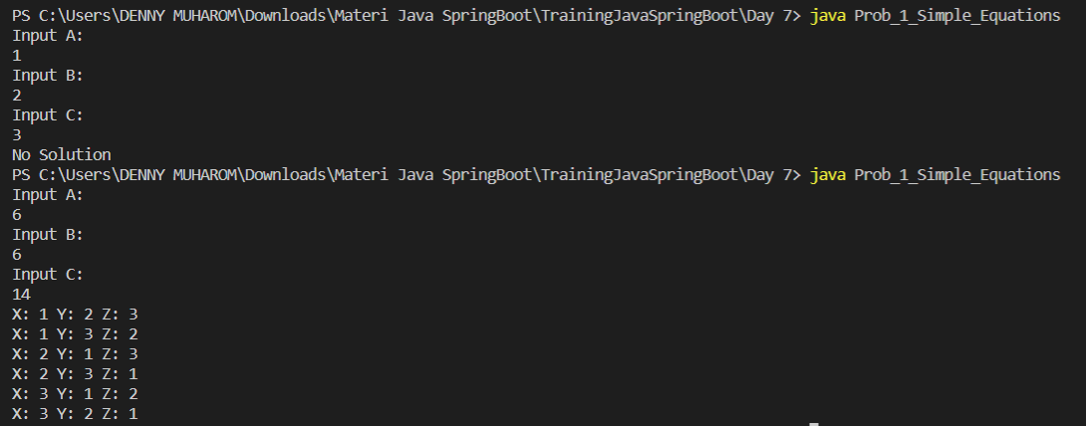

**Problem 2 - Money Change**



**Problem 3 - Dragon of Loowater**



**Problem 4 - Binary Search Algorithm**



**Dynamic Program**

**Problem 1 - Fibonacci Number Top Down**

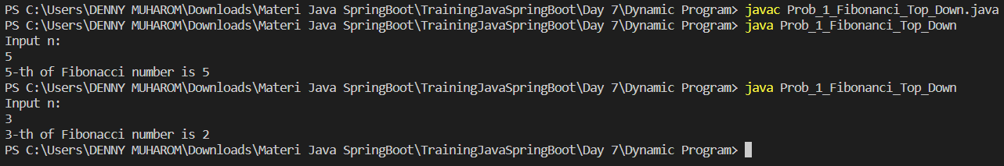

**Problem 2 - Fibonacci Number Button Up**

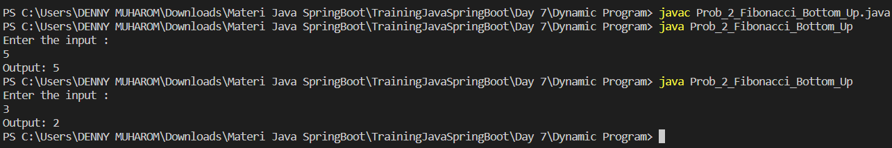

**Problem 3 - Frog**

**Problem 4 - Roman Numerais**

